Pro

IGT

Termination Requests

**IGT**

6/19/2015

STG Tools Team

User guide to complete a termination request for JIRA and PartnerJIRA.

Table of Contents

Revision Table 2

Section A: Checking a user in Production JIRA 3

Section B: Checking a user in Partner JIRA 8

Section C: Bulk Edit Termination Requests to next Employee 13

Appendices: Special Cases of Termination Requests 16

# Revision Table

|  |  |  |  |
| --- | --- | --- | --- |
| Version | Date | Team Member | Revision |
| 1.0 | 6/19/2015 | Stephen Bell | None |
|  |  |  |  |
|  |  |  |  |

# Section A: Checking a user in Production JIRA

1. Login into the Production Instance of RIJIRA
   * <https://rijira.gtk.gtech.com:8443/jira/secure/Dashboard.jspa>
2. Open up Termination Request from email using the link provided in the email. Enter username and password if needed **OR** open up the termination request in JIRA using a filter to filter the requests assigned to you. (Easiest way is to use the emails)

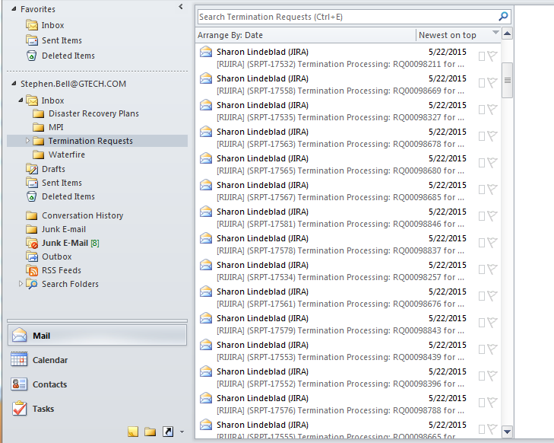

Figure : Example Termination Requests in Email

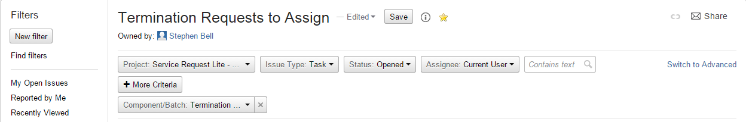

Figure : Filter to use to search for Termination Requests assigned to you

1. Log into **another** instance of Production JIRA (RIJIRA). Only do this if needed if you decided to use a filter instead of the emails.
2. In the first instance of RIJIRA you opened in Step 1, enter Administration->Users to search for usernames within the system. Enter your password (If needed).
3. Use “Full Name Contains” to search by name, **not** by username

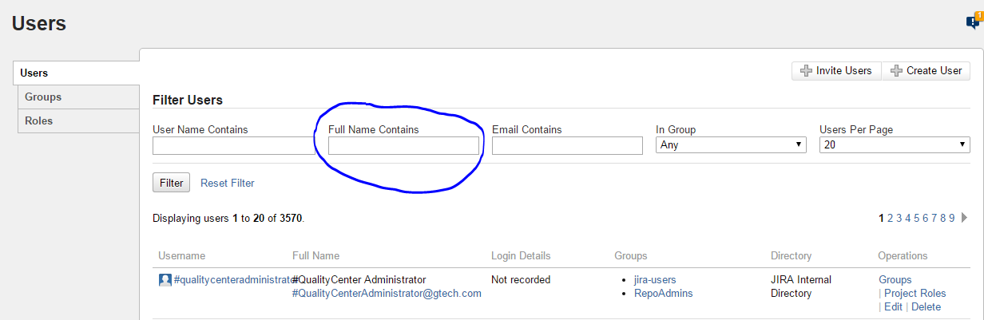

Figure : How to search for a user

1. Search by Last name or by First name Last name using name in the termination request.
   * Ex) Bell **OR** Stephen Bell
   * **Be careful of extra spaces before and/or after last name or first name. This will affect the results of the query.
2. If person is a user in JIRA, click on their username on the left. If not a user, in the termination request for this user, next to JIRA, replace “Incomplete” with “Not an active user”. **Move on to Section B**.



Figure : Location of username

1. Click on “Edit Groups”

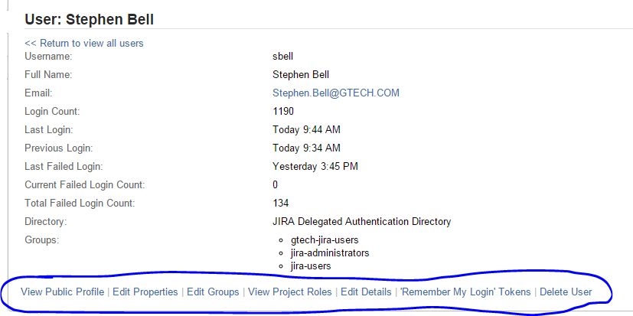

Figure : Bottom navigation bar for next steps

1. Click on each group user is in, and click on leave

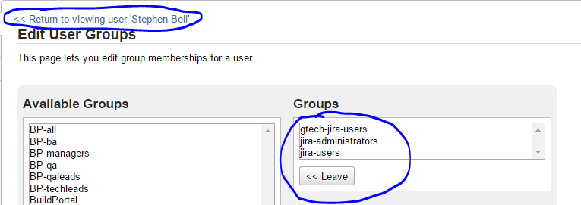

Figure : Edit Groups Screen

1. Click on “Return to viewing user “Person’s name”. (You may need to scroll up on the page)
2. Next, click on “View Project Roles” on the bottom navigation bar.
3. Click on “Edit Project Roles” (At the bottom of the page) and uncheck any roles the user may be in. Then click Save. If the user is in no roles, you can move on to the next step.

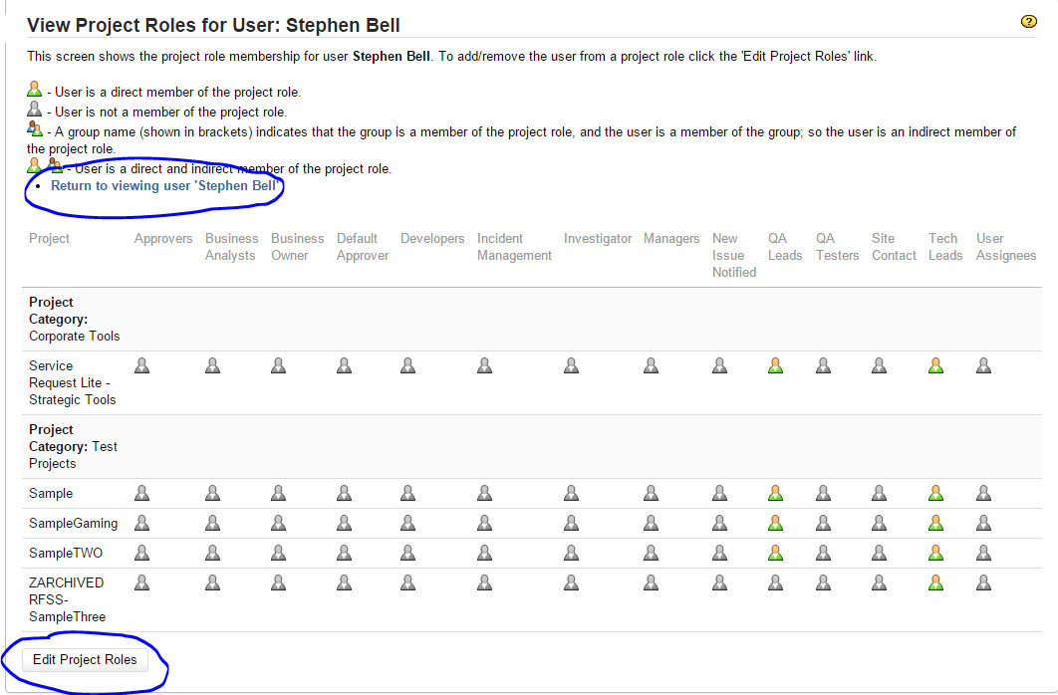

Figure : Project Roles Page

1. Click on “Return to viewing user “Person’s name”
2. Lastly, click on “Edit Details”
3. Uncheck the “Active” box

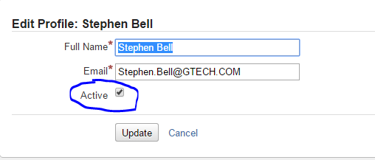

Figure : Edit Details Screen

1. Click update
2. Click on “Users” in the left nav bar to return to User Search page. The Full Name of the person should have a line through their name, meaning they are not an inactive user.
3. In the termination request for the user, next to JIRA, replace “Incomplete” with “Removed from all groups, project roles, and set inactive”.

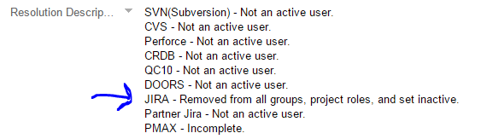

Figure : Example Termination Request

1. Move on to Section B to check to see if the user is a user in Partner JIRA.

# Section B: Checking a user in Partner JIRA

1. Login into the Production Instance of Partner JIRA
   * <http://rigtpjira:8080/jira/secure/Dashboard.jspa>
2. The current termination request should still be opened. If not, reopen the termination request from your email or from the filter you set in Section A in a separate instance of Production JIRA (RIJIRA)



Figure 8: Example Termination Requests in Email



Figure 9: Filter to use to search for Termination Requests assigned to you

1. Enter Administration->Users to search for usernames within the system. Enter your password (If needed).
2. Use “Full Name Contains” to search by name, **not** by username



Figure : How to search for a user

1. Search by Last name or by First name Last name using name in the termination request.
   * Ex) Bell **OR** Stephen Bell
   * **Be careful of extra spaces before and/or after last name or first name. This will affect the results of the query.
2. If person is a user in Partner JIRA, click on their username on the left. If not a user, in the termination request for this user, next to Partner JIRA, replace “Incomplete” with “Not an active user”. **Mark email as read for termination request and move onto another Termination Request, and back to Section A. If there are no more, move onto Section C**.



Figure : Location of username

1. Click on “Edit Groups”



Figure : Bottom navigation bar for next steps

1. Click on each group user is in, and click on leave

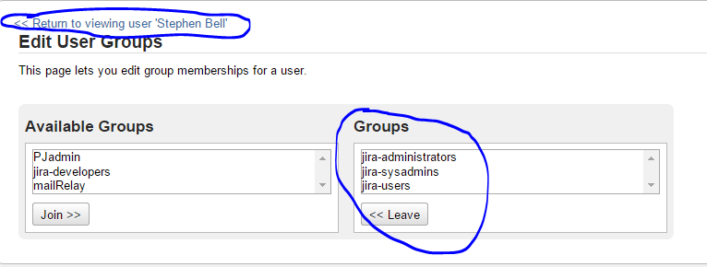

Figure : Edit Groups Screen

1. Click on “Return to viewing user “Person’s name”. (You may need to scroll up on the page)
2. Next, click on “View Project Roles” on the bottom navigation bar.
3. Click on “Edit Project Roles” (At the bottom of the page) and uncheck any roles the user may be in. Then click Save. If the user is in no roles, you can move on to the next step.



Figure : Project Roles Page

1. Click on “Return to viewing user “Person’s name”
2. Lastly, click on “Edit Details”
3. Uncheck the “Active” box



Figure : Edit Details Screen

1. Click update
2. Click on “Users” in the left nav bar to return to User Search page. The Full Name of the person should have a line through their name, meaning they are not an inactive user.
3. In the termination request for the user, next to Partner JIRA, replace “Incomplete” with “Removed from all groups, project roles, and set inactive”.

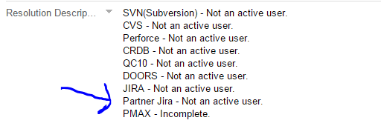

Figure : Example Termination Request

1. Move on to Section B to check to see if the user is a user in Partner JIRA.

# Section C: Bulk Edit Termination Requests to next Employee

1. Once all termination requests have been complete, they need to be assigned to the next person so they can complete their section. The easiest way to do this is to bulk edit all the issues at once.
2. Create a filter with the following fields populated. You can save this filter to use for future references.
   * 1. Project: Service Request Lite - Strategic Tools
     2. Issue Type: Task
     3. Status: Opened
     4. Assignee: Current User
     5. More Criteria ->Component/Batch: Termination Requests

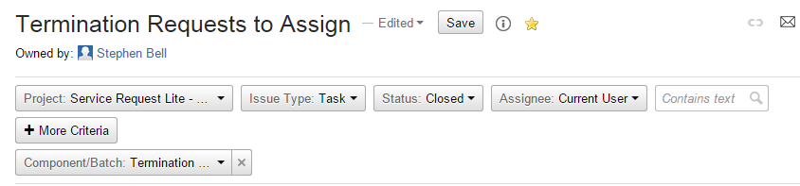

Figure : Termination Request Filter

1. Once the filter is created or you have accessed the filter, click on the cog wheel in top-right corner, and click on the link under **Bulk Change:**

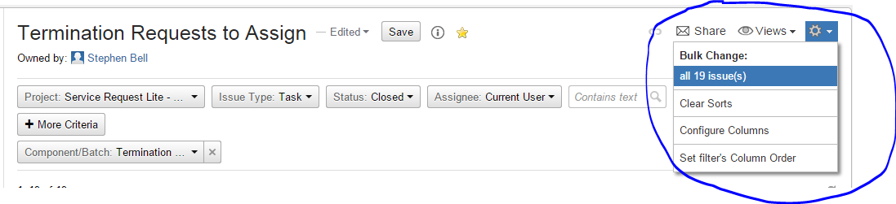

Figure : Bulk Change

1. Choose all the issues, and click Next

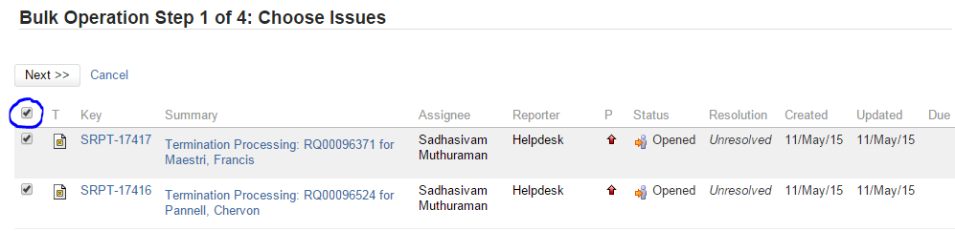

Figure : All Issues to Bulk

1. Choose to Edit the Issues, then click Next
2. Change the assignee to Ronal Storey

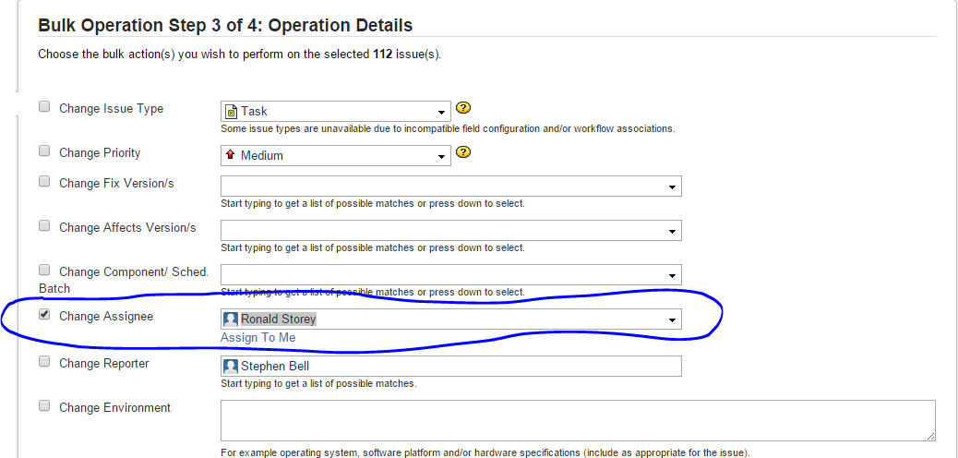

Figure : Who to assign issues to

1. Make sure there will be email notifications for these changes by seeing if the check box at the bottom is checked. (At the bottom of the page)

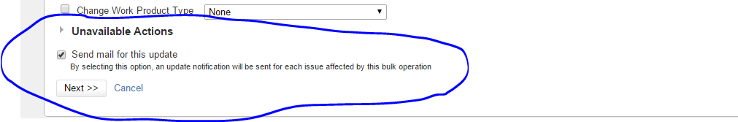

Figure : Email Notifications

1. Confirm the changes to change the assignee fields for all the issues, and the click Confirm.

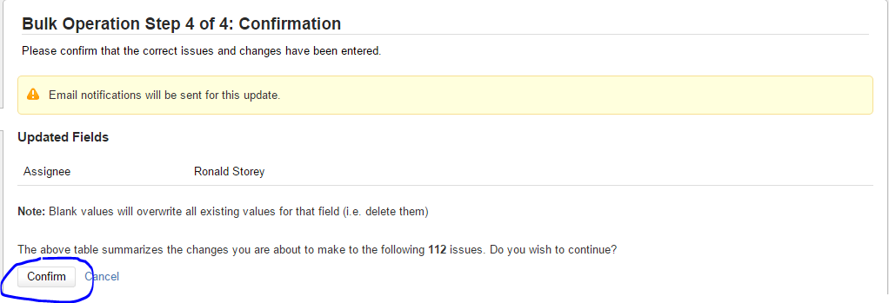

Figure : Confirm Changes

# Appendices: Special Cases of Termination Requests

1. **The user is already inactive in JIRA or Partner JIRA**
   1. Check to see if there was already a termination request for this user by changing the filter to search for the users name with termination in front of it (Termination “user’s last name”), changing the Status of the issue to Closed, and changing the Assignee to All. For example:

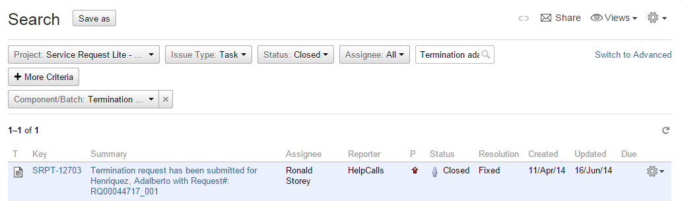

* 1. If there is already a request, write down the issue ID (For example, SRPT-1923), go to the current termination request for this user and click on More Actions, and click on Link. If there is not a duplicate request, in the termination request for JIRA and/or Partner JIRA, replace “Incomplete” with “Removed from all groups, project roles, and set inactive.”

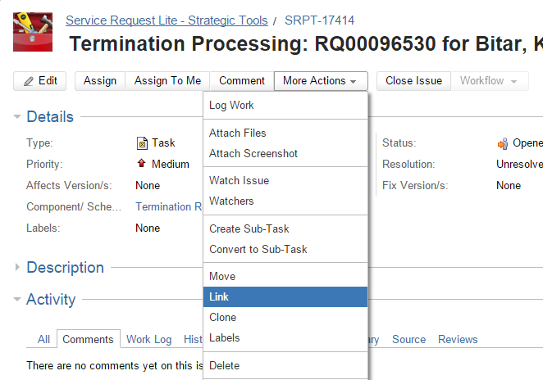

Figure : More Actions

* 1. On the link screen, choose “Duplicate of” for This Issue, and then in the Issue search box, search for the duplicate issue using the issue key written down in step 2. Click on that issue. Then click on Link. A link to the duplicate issue will be created in the current issue.

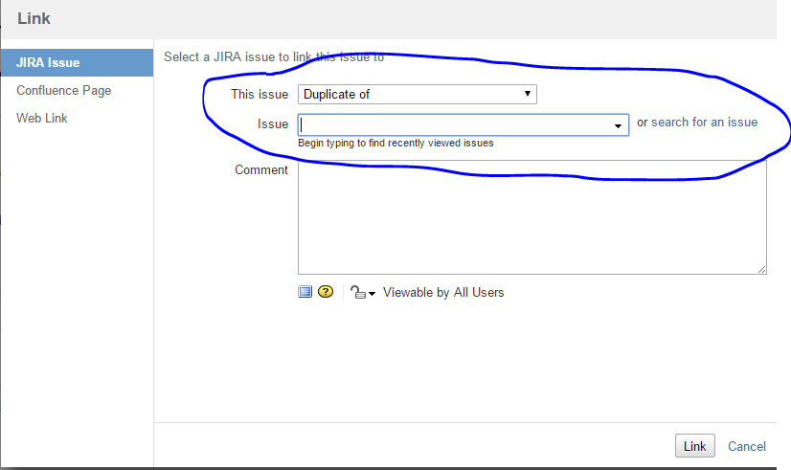

Figure : Link Screen

* 1. Lastly, close the current termination by clicking on “Close Issue”.

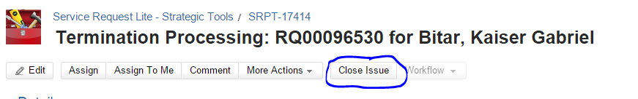

Figure : Close Issue